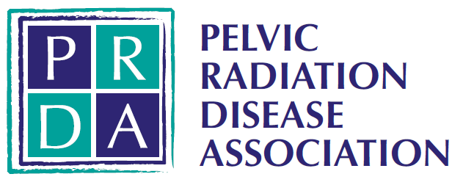

Trustee and Treasurer Role Description

About The Pelvic Radiation Disease Association (PRDA)
Pelvic Radiation Disease (PRD) is a long-term side-effect (‘late effect’) of pelvic radiotherapy treatment affecting an estimated 100,000 people in the UK. People affected by PRD often have a complex set of symptoms affecting the bowel, bladder, sexual function or other functions for many years after radiotherapy, sometimes only appearing several years after radiotherapy treatment.
PRDA is a small UK charity working to raise awareness of PRD so that the effects of PRD are minimised, that people affected by PRD are given the best possible care and treatment, and that PRD is accepted as a serious problem and given the attention it deserves.
Being a Trustee
The board is made up of six trustees, plus a Chair, who bring a wealth of experience, knowledge and passion. The trustees are responsible for setting the strategic direction of the charity, managing finances and developing opportunities to increase the profile and impact of the charity.

As a small charity navigating the current challenging landscape with an increased demand for our services and support, we are seeking to become more financially sustainable in the longer term and grow our work. For this reason, we are looking for trustees with experience of fundraising and finance. Our current treasurer is seeking to step down from this role at the end of 2026, and therefore we need someone with skill and expertise to cover this vital area of work.

Trustees meet approximately 4 times a year online, with an annual in-person strategy day, usually in January. There are opportunities to represent the charity at networking events across the year.

Treasurer: Specific Responsibilities

Financial oversight and controls: oversee the financial affairs of the charity and review and monitor internal financial controls, delegations, reserves, cash flow and bank arrangements recommending improvements where required to ensure value for money and compliance with the Charities Statement of Recommended Practice (SORP) FRS 102-2019-a and subsequent applicable versions.

Accounts: ensure annual accounts and other reporting requirements are prepared and submitted to the Charity Commission, Companies House and OSCR (Scottish Charity regulator) on time.

Reports: prepare and present financial data in an easy-to-understand format and provide advice and guidance to the Board on a range of financial matters, including risk.

Budgeting and Financial planning: lead the annual budget process, and agree a reserves policy appropriate to the size and risk profile of the charity. Advice the Board on financial implications of strategic decisions or funding opportunities.

Shared Responsibilities

- Ensure that PRDA operates in line with the charity purposes and governing document.
- Contribute actively to the board of trustees by giving firm strategic direction to PRDA, setting overall policy, defining goals, setting targets, and evaluating performance against agreed targets;
- Ensure that PRDA upholds its commitment to equality, diversity and inclusion across all its activities;
- Safeguard the good name and values of PRDA, and
- Act in the best interests of PRDA and its beneficiaries at all times
- Profile and represent the charity to raise awareness and increase funding opportunities.

Person specification
- Empathy with PRDA’s mission and the people we support
- Demonstrable experience of relevant financial management skills
- Understanding of charity finance and statutory requirements
- Able to communicate financial information to those without finance background
- Sound judgement, integrity and a commitment to good governance
- Strategic thinker
- Creative thinker and solutions minded
- Collaborative, respectful approach and willingness to challenge constructively

Terms
The Treasurer role typically involves 6-10 hours per month, but there may be periods when more hours are required.

Trustees are appointed on an initial three-year term.

The role is not paid, however reasonable travel expenses can be claimed in line with PRDA Expenses Policy.

Appointment Process
For an informal chat about the role, please contact us via Reach in the first instance and we will arrange for someone to give you a call.

Applications will be by CV and Covering Letter. CV’s alone will not be accepted.
Shortlisted candidates will be invited to an online interview.
References will be obtained for successful candidates.

